Dorset and Wiltshire Vascular Network
Clinical Meeting

This is to certify that
Theresa Fail

attended the meeting on
Thursday 11th January 2018
At Salisbury District Hospital
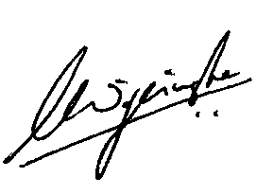

Mr Lasantha Wijesinghe
Organiser

