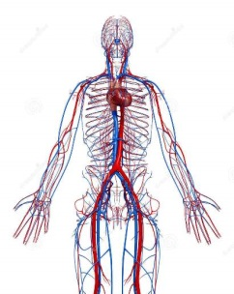
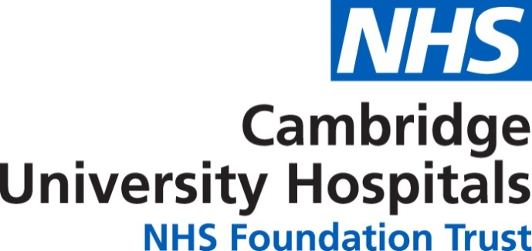

Certificate of attendance
………Laura Scott……………

Attended the vascular nursing study day on the 06/11/2019
7.5 hours CPD

