
Liverpool University Hospitals
NHS Foundation Trust

This is to certify that

Steven Wallace

Attended a Professional Development Conference

Large Vessel Vasculitis Meeting

Friday, 13 October 2023
Held at
Doubletree Hotel, Chester

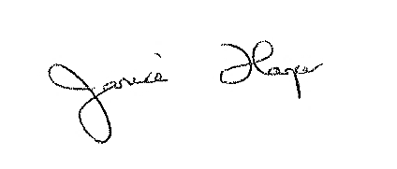
______________________
Course Organiser

Large Vessel Vasculitis meeting (code: 146248) has been approved by the Federation of the Royal Colleges of Physicians of the United Kingdom for 6 category 1 (external) CPD credits.
