Certificate of Attendance
Certifies to all that
Sara Causley
attended
The Vascular Societies' Annual Scientific Meeting
Wednesday 1 November - Friday 2 December 2016, Manchester Central
Registration Type
SVT Member - Thu Only
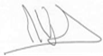 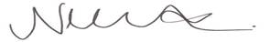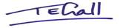
Mike Wyatt, President, The Vascular Society
Nikki Fenwick, President, Society for Vascular Nursing
Tracey Gall, President, Society for Vascular Technology

