Certificate of Attendance
Certifies to all that
Daniel Harding
attended
The Vascular Societies' Annual Scientific Meeting
Wednesday 30 November - Friday 2 December 2016, Manchester Central
Registration Type
SVT Member - Full Conference
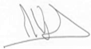 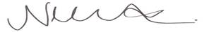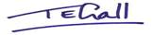
Mike Wyatt, President, The Vascular Society
Nikki Fenwick, President, Society for Vascular Nursing
Tracey Gall, President, Society for Vascular Technology

