
This certificate is awarded to:
Heather Holmes
For participating in a clinical audit
'An audit of adherence to local carotid ultrasound protocols 2017.'
08 June 2018
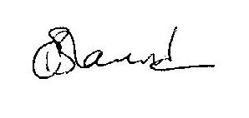
Dr Christine Blanshard
Medical Director

