Canon Vascular Days – Peripheral Artery Disease: Non-Invasive Imaging
Wednesday 3 April 2024
- Lower Limb Doppler Waveform Interpretation in Challenging Cases | Dr. Matt Bartlett - presentation on Doppler wave profiles and how they can be used to diagnose arterial perfusion
  - As the pressure gradient decreases, flow lessens
  - As the distal resistance increases, flow lessens
  - Systolic rise time demonstrates a good correlation with ABPI
  - Increased spectral broadening indicates disturbed flow
  - The mean velocity tracing can help to demonstrate the amount of spectral broadening present
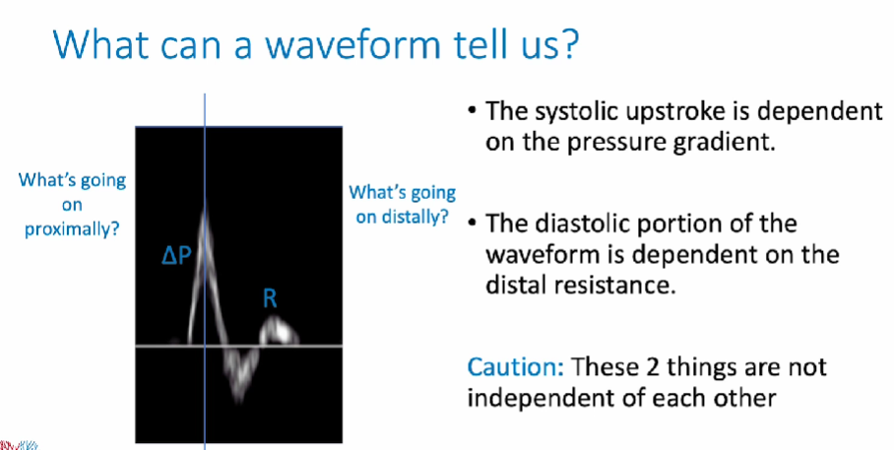
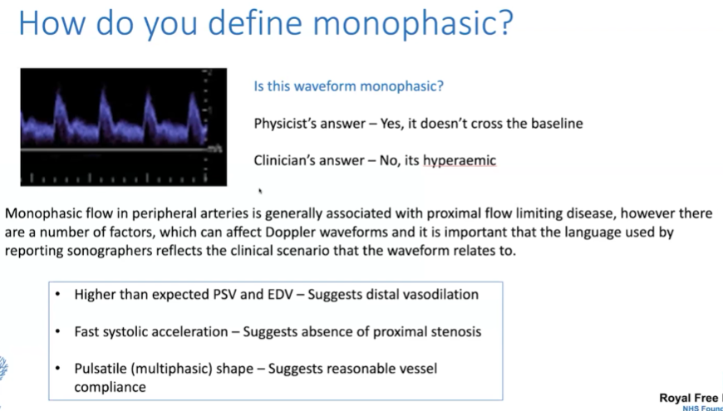
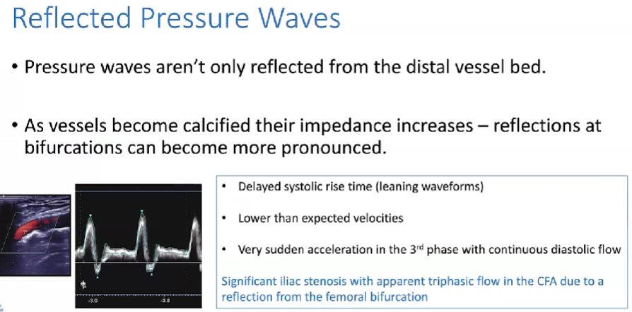

- Advanced CT Imaging in Peripheral Artery Disease | Prof. Catherine Roy - presentation on SureSubtraction software for CTA.
  - Can provide extremely detailed picture of flow, even calcified calf and pedal vessels
  - Traditional recontruction time-consuming; SureSubtraction very quick, and can use low-dose contrast
  - Automatic1-click process which takes 3-5 minutes
  - Better identification of tiny vessels and collateral circulation than previous methods; however, very aggressive algorithm, and has a tendency to over-call severe disease
- Clinical Cases in Vascular Imaging | Dr. Kanae Mukai - Presentation comparing imaging techniques. Prefers the use of no contrast MRA

