Pathway of Vascular U/S referrals

- IP that are suspected ischemic and urgent are to be seen by vascular team first to be determined if vascular U/S needs to be done ASAP.

- IP that are non-urgent and non-ischemic with leg swelling,? Palpation of foot pulses
To Perform ABPI or to exclude asymptomatic vascular disease and need U/S scan are to be referred to Radiology for scan at earliest convenience do not need vascular review.

- Non urgent IP/OP clinical vascular referrals are seen by vascular consultants in clinic and/or on wards will come to us as OP referral and appointments given.

- If demand is too high against capacity then Radiologists will support the Vascular sonographers in prioritising workload.

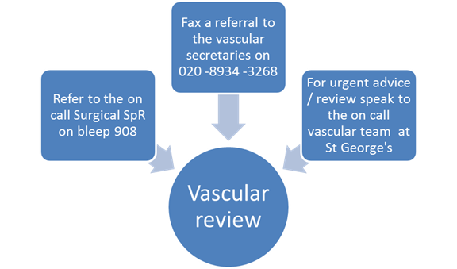

Golnaz Morshedian Lead Vascular Sonographer
Dawn Warrington Clinical Lead Sonographer
Jim Weir Radiology Manager
Vin Majuran Clinical Director Radiology
Sudip Ray Consultant Vascular Surgeon
December 2016

REFLECTIVE CPD ACTIVITY FORM

Name: Golnaz Morshedian

Job Role: Lead Vascular Sonographer/Scientist

Description:  (i.e. SVT AGM 2017, presented at local meeting) | Pathway of vascular U/S referrals presented to Radiology department, discussed at vascular meeting and checked with supervisor to make this pathway a hospital policy.
Date(s): | 12__ / 11__ / _16_ ( to 12__ / _12_ /_16_ ) Total Days/Hours_________a month______
Type of activity: | □ Educational □ Professional □ Work-based □ Self Directed  □ Other ________________________
Benefits to your practice: | This policy has become a much easier way to direct our vascular load of work for ultrasound into a more robust service.
Benefits to service user: | The benefit of this policy has saved our department time for other more urgent vascular referrals. Prior to this , anyone in the hospital without even have seen the patient properly or checked pulses could request a vascular scan.  This started because more and more normal scans were made out to be ‘’urgent’’ scans. Unnecessary referrals would get in our way of scanning real urgent cases and more disappointed patients, and consultants.  We now have real cases with a vascular consultant having to assess patient before requesting a scan. It didn’t only save more timeslots for us to fit other urgent scans in, but it saved the patient an extra day or hours od having to spend in the hospital, waiting for a scan that wasn’t needed to begin with. In that order, then it also saved beds for the hospital for other patients.
Supporting evidence:  (can include program certificate, notes, presentation, signed training sheet) | An attachment of policy has been attached to SVT personal website for CPD points.
Additional notes: | All names on the attachment are there because it had to be approved by all radiology superior staff. Policy and pathway layout and idea was created by myself.

