06.04.22 | L6 vascular working group module writing (with virtual teams meeting and offline writing)
Type of Learning | Professional
Activity overview | The level 6 apprenticeship vascular working group have been meeting monthly since Oct21. The group consists of 4 NHS vascular scientists (CVS) and a senior lecturer at Gloucester University. Three of the CVS are involved in the SVT Education Committee and there’s myself who became involved through my work as a fellow with Health Education England (HEE). The group meets virtually to discuss the progress of putting together a L6 apprenticeship (undergraduate degree level) to start in September 2023. The main focus in the two months has been to agree the module titles. These are now in place and the current phase is to write the learning objectives and module content - I have taken responsibility for writing the two extracranial modules at 30 credits. This CPD activity is reflective of work completed 06/04/22 – virtual Teams meeting to agree a plan and offline writing – next meeting early May.
Benefits to own practice | Filling my own knowledge gaps – I didn’t know much about apprenticeships and alternative education routes other than what I had studied for (STP and AVS). Working on the development of this L6 apprenticeship course has hugely increased my knowledge on apprenticeship routes and I have been able to share this knowledge with colleagues.  This CPD activity has given me opportunity to allocate protected time to examine the new Sep22 STP learning objectives – which will be beneficial when our new STPs start in September. I have used this curriculum to align with the proposed L6 practitioner learning objectives, while continuously thinking what is our vascular science workforce missing? How can we design this degree to fill our recruitments issues? And how can we future-proof our profession? Introducing a practitioner role, will provide a more flexible vascular science workforce that vascular departments can recruit from.  This activity has also giving me new opportunities to work with vascular scientists nationally and education providers at Gloucester University. It’s an exciting innovative project, which is aligned with national diagnostic recommendations from the Richard’s review.
Benefits to service users | Most physiological healthcare science specialisms have a practitioner model (cardiac, respiratory, audiology, ophthalmology, and neurophysiology) but vascular has been forgotten. Introduction of this undergraduate course will allow students to enter a career in vascular science as a vascular practitioner. The course will be designed to give students the skills to work in an NHS vascular department. Currently our AAA screeners and ABPI technicians have no career route for progression unless they already have a good science degree and can secure a position on the STP or study for AVS.

EVIDENCE 1: Meeting invite
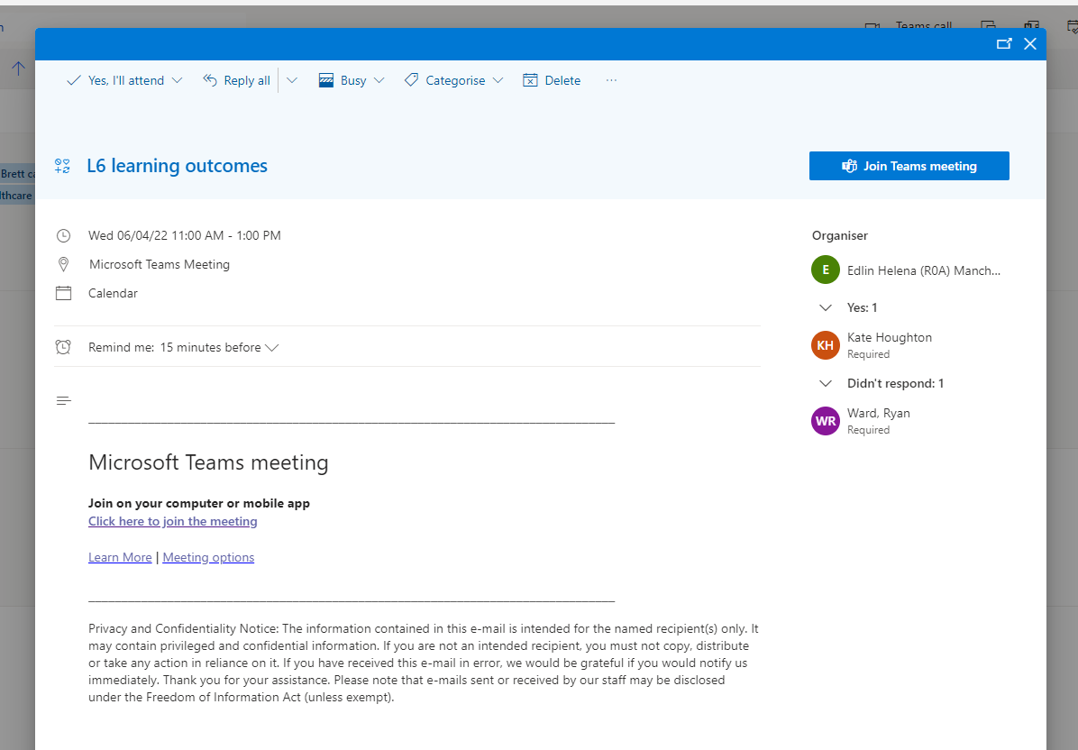

EVIDENCE 2: Proposed module content - (blacked-out due to draft version)
