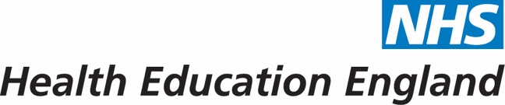

This is to certify that

Vikki Galgerud

was a faculty member for the
North West School of Surgery

Vascular teaching day:

6 December 2021

Mr Jon Ghosh
Training Programme Director

