ASPIRE Webinar Feb 6th 2023
"Whats new and exciting in the world of renal access surgery" led by Mr Karim Elsakka ,Coventry
This webinar will focus on novel surgical techniques including legs grafts / WaveQ, HERO grafts and endoAVF as well as looking a new trends in fistula salvage.

Evening lecture had 4 speakers and mainly dealt with novel approaches to vascular access

One speaker spoke about problems with SVC obstruction and discussed use of hero graft. This graft goes through the central venous obstruction into the atria, allowing dialysis access. Although it has its place he did stress that it is not a perfect solution and will generally require 2 to 3 interventions a year

2nd speaker discussed angioplasty and stenting of fistulas , in particular the use of drug eluting balloons/stents

3rd speaker discussed endoAVF formation – there are now a couple of devices on the market that form an AVF endovasclarly, device is put in superficial vein at where vein and artery are in close contact, catheter is pushed through into artery and essentially ‘burn’ a hole through the vein and artery wall forming a fistula. Done under ultrasound guidance (Ellipsys device or Wavelin Q)

Another speaker discussed use of leg grafts

Also use of VasQ device – this is placed around a BCF ,BVT or RCF anastomosis to keep anastomosis at ideal shape and prevent anastomotic stenoses developing.
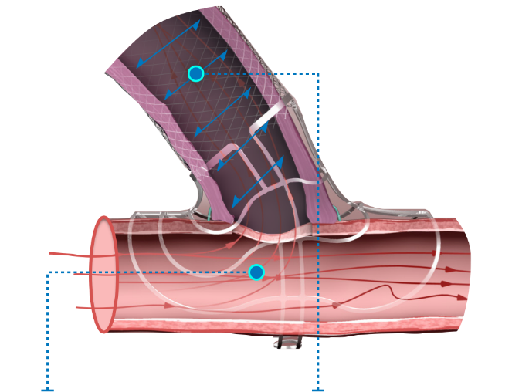

Reflection: Interesting to learn about fistulas that we may end up scanning, in particular the endoAVF formation which is done under ultrasound guidance.

Action – mentioned up to date kDOQI guidelines – aware that I haven’t read the most recent ones. Have printed them off as further reading.

