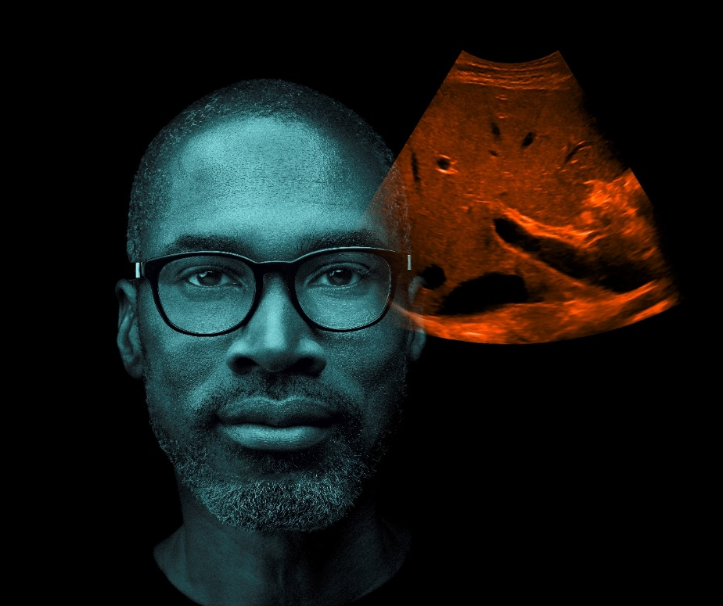
A new era in ultrasound
ACUSON Family

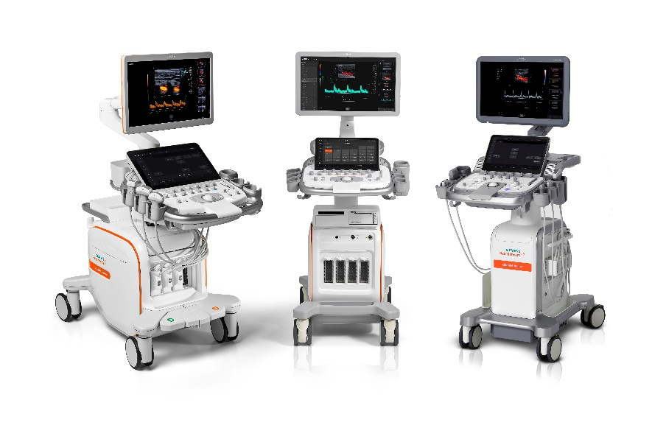

Agenda
Fintan Gunne Theatre, Catherine McCauley Centre, Nelson Street, Dublin 7.
Thursday 14th November
16:30 | Registration and networking
17:00 | Welcome | Edel Murrin
17:10 | A new era in Ultrasound | Judith Cuthbert
17:30 | Importance of on-going education | Tracey Gall
17:40 | Introduction to contrast enhanced ultrasound of the liver | Tracey Gall
17:55 | Colour optimisation techniques using ACUSON technology | Tracey Gall
18:10  18:30 | Live scanning with the new Siemens Healthineers Ultrasound portfolio  Hors d'oeuvres and networking

