

VASCULAR NETWORK - DUPLEX MEETING
Wednesday 31st January 2018. 10am to 12.30pm
Lecture Room A, South Academic Block, C level,
Southampton General Hospital. Tremona Rd, Southampton SO16 6YD

AGENDA
1. Welcome, Apologies and Introductions (Alison Charig)
2. Introduction to South Central Vascular Network and requirements for Vascular Duplex. (Mr Ian Nordon, Vascular Surgeon)
3. Overview of each Vascular Duplex Service (representatives from each centre)
4. Group Discussion - Carotid Duplex, to include:
- reporting
- diagnostic criteria
- scanning protocols
- SVT document
5. Planning future meetings

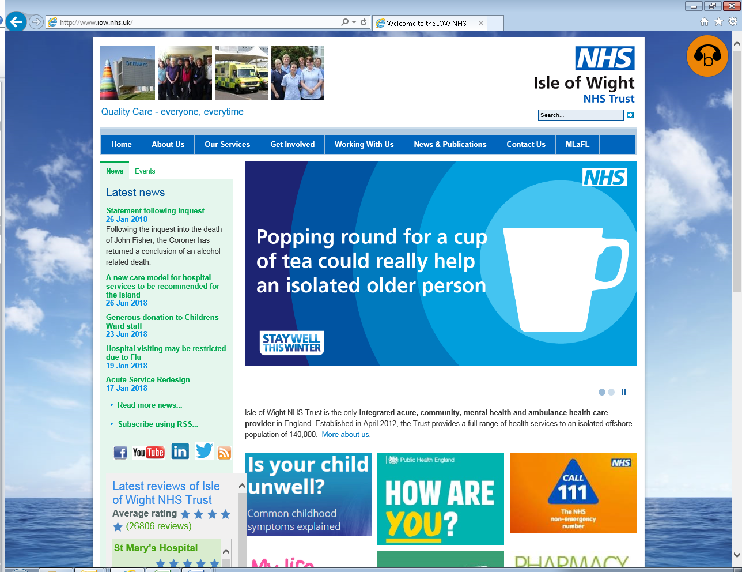
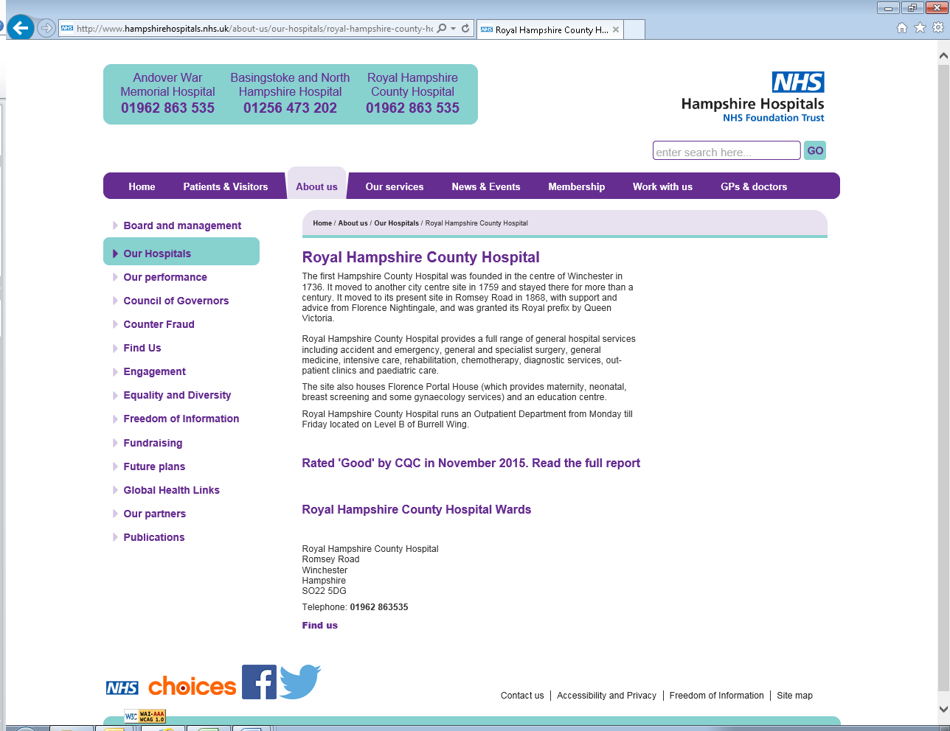
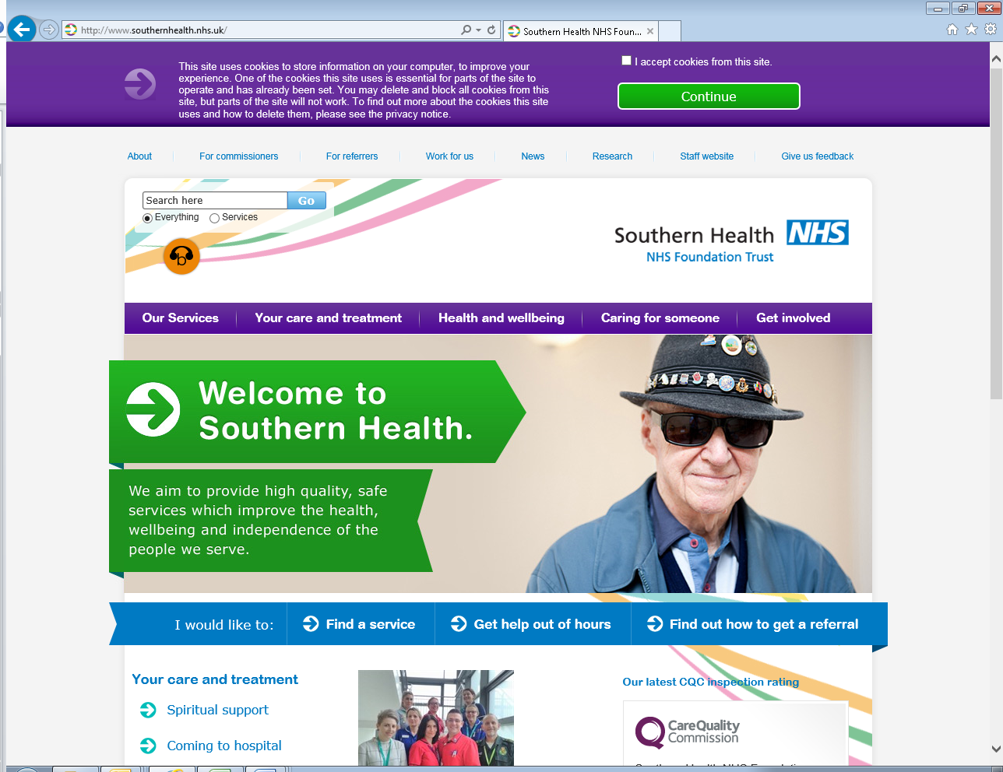
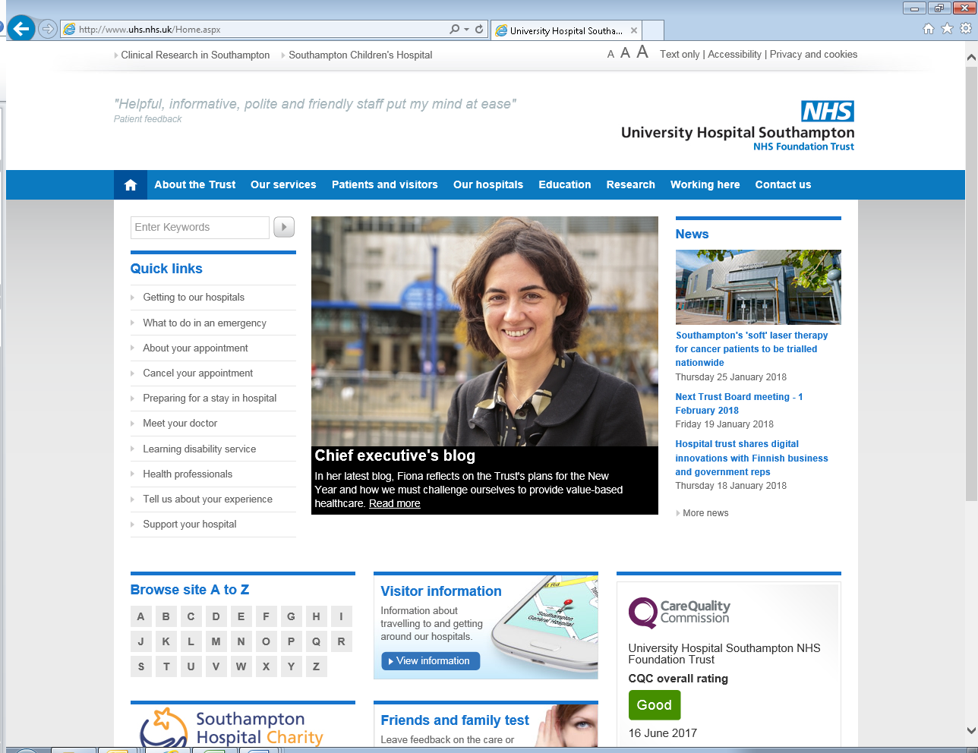


Alison – mobile – 07855 666020
