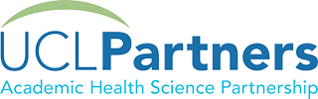

Neurovascular Carotid MDT Governance meeting
19th January 2024

Certificate of Attendance

On behalf of the Neurovascular Carotid MDT we would like to thank

Matthew BARTLETT

For attending and contributing to the Governance Meeting.

Your contribution will have significantly helped to maintain good and safe patient care

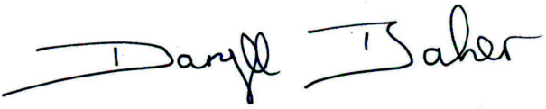

Daryll Baker
MDT Co-ordinator
Consultant Vascular Surgeon
Royal Free London NHS Foundation Trust

