ASPIRE Junior – Management of Ulcers, Rouleaux Club Webinar, 30/06/2022
Ulcers:
- Loss of epithelium
- present in 2% of population
- Absorb 2% of NHS budget
- 70% venous
- Remainder arterial, neurogenic, vasculitides (autoimmune disorders); the latter not covered by this talk.
Arterial:
Chronic Limb-Threatening Ischaemia (CLTI)
- Ischaemic rest pain confirmed by haemodynamic test: ABPI < 0.5, toe pressure < 50 mmHg, etc.
- Ulcer > 2 weeks
- Gangrene
- Diabetic foot ulcer
- Broader definition than Critical Limb Ischaemia (CLI)
Arterial ulceration/gangrene (wet or dry) with progressive tissue necrosis.
Rest pain – deep pain between the metatarsal heads.
Perfusion assessment is paramount.
Clinical history to include:
- Risk factors for peripheral arterial disease (age, sex, diabetes, hypertension, smoking history, high cholesterol, relevant family history, etc.)
- Medications: anti-coagulation, antiplatelet, statins, etc.
- Is the patient sleeping?
- Leg dependency to increase perfusion/reduce pain?
Clinical examination to include:
- Ulcer appearance; typically punched out and deep.
- Shiny, hairless skin.
- Rubor, sunset foot.
- Palpate pulses and assess capillary refill.
- Buerger’s test: dependent colour change (pallor on elevation, rubor on dependence). Compare this with constant rubor with inflammation.
- ABPI, toe pressure, toe SpO2
- New ABPI ranges (NICE):
0.9 ≤ ABPI ≤ 1.1 Normal
ABPI < 0.9 Peripheral Arterial Disease
ABPI > 0.5 Typically claudicant
ABPI < 0.5 Usually rest pain
Management:
- Admission?
New targets are revascularisation within 5 days if an in-patient, 2 weeks if an out-patient.
- Are there signs of end organ dysfunction?
- Analgesia
- Risk factor modification:
75mg Clopridogerol, 80 mg statin or higher dose if tolerated, control hypertension and diabetes, smoking cessation.
- Bloods including full blood count and renal function electrolytes.
- ECG
- Imaging: Duplex ultrasound 1st line; MRA/CTA 2nd line as appropriate.
- Revascularisation
- Amputation
- Conservative (best medical treatment, analgesia, palliative care)
Revascularisation:
- Is revascularisation appropriate for the patient?
- Assessment of risk (low risk with life expectancy > 2 years)
- Limb staging
- P - Patient high/low risk
L - Limb staging according to the WIFI scoring system
AN - ANatomy: target arterial path to restore inline flow to the foot
- Inflow-Conduit-Run-off
- Stenosis versus Occlusion
- Degree of calcification
- Segments involved, typically divided into aorto-iliac, infrainguinal and infrapopliteal.
- Options include endovascular, open, or hybrid.
Diabetic Foot Ulceration:
- Pattern different to peripheral arterial disease (PAD)
- c. 50% will have underlying PAD
- sensory, autonomic, and ischaemic neuropathy (and combinations)
- sensory neuropathy leading to repetitive minor trauma
- autonomic neuropathy leads to an absence of sweating and the build-up of calluses with tissue death underneath, shortening of tendons and toe clawing.
- Combination of micro and macro-vascular disease
- Increased prevalence of infection in comparison to PAD patients
- Classic PAD symptoms may be absent
Examination:
- Ulcer location
- Calluses?
- Infection?
- Physical examination as arterial ulcer + sensation, is there evidence of neuropathy?
- ABPI but with caution; toe pressures better due to tibial incompressibility
Management:
- Control of sepsis:
Bloods
Foot X-ray, primarily looking for gas in soft tissues, secondarily bony destruction
Antibiotics
Urgent surgical drainage
- Imaging:
Duplex, MRA and CTA often limited by calcification
Often angiography with immediate procedure to revascularisation
WIfi Scoring
- Wound Ischaemia Foot-Infection staging (I to IV)
- 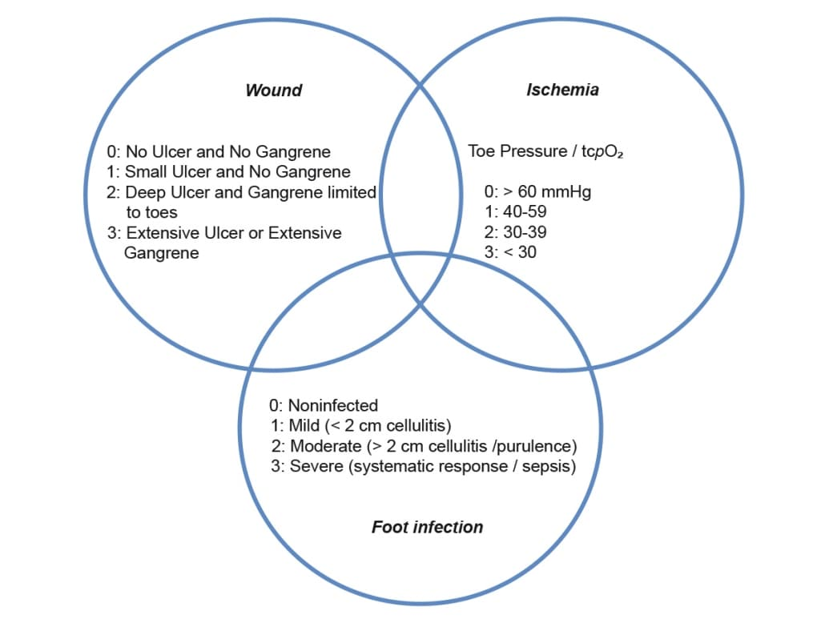
- Identifies risk of amputation at 1 year
- Useful as doctors, etc. notoriously bad at identifying pulse phases with CW and feeling foot pulses.
- Patient can be re-scored after treatment.
Management of Venous Ulcers
Venous Hypertension:
- 90% superficial ± deep venous reflux
- 10% deep venous reflux only (not considered in this talk)
Ulceration results from:
- Oedema: increased distance between epidermis and vessels
- Stasis : leads to ‘white cell trapping’ – inflammation, oedema, fibrosis, all leading to reduced perfusion
Clinical history to include:
- Duration
- Trauma?
- Pain assessment
- Anticoagulation status
- Varicose veins?
- Previous history of DVT, varicose vein treatment
- Family history
- Social history, quality of life: ulceration often leads to social restriction, avoidance, and a reduced quality of life.
Examination:
- Ulcer location (typical medial malleolus)
- Size
- Depth
- Base
- Skin edges
- Infection
- Quality of surrounding skin
- Pulses
- Check for varicose veins
- Signs of venous hypertension
- ABPI but with usual provisos
Management:
NICE guidelines in order of decreasing effectiveness:
- Endovenous ablation
- Foam sclerotherapy
- Surgery
- Compression
- Vascular referral
- ABPI with arterial work-up if ABPI < 0.7
- Venous Duplex to identify pattern of reflux
- Endovenous ablation within 2/52 ± local treatment of varicosities (surgery/foam)
- VTE prophylaxis and TEDS
- Re-assessment in clinic re. wound healing
Wound Care:
- No evidence for any one type of dressing over another
- Antibiotics if signs of infection
- Swabbing generally not necessary (most will demonstrate bacteria w/o infection occurring); only swab if infection does not respond to antibiotics.
98% of NHS spend on venous ulceration is in primary care, but poor effectiveness of primary care treatment. 75% of patients do not receive adequate vascular assessment.

