ASPIRE 5 |   


  - Annual Specialist Registrar Educational ST5 Programme
4th-6th May 2022
Midlands Art Centre, Cannon Hill Park, Birmingham. B12 9QH

Welcome

A very warm welcome to Birmingham for ASPIRE 5
.
The content has been aligned to the National Vascular curriculum and covers EVAR planning and deployment, peripheral simulation and closure devices, clinical scenarios and open surgery

The organising committee are very grateful to Cook Medical, Gore, Getinge, Terumo and Abbott for their educational support for this event

Please join us for the programme dinner at 19:15 on Thursday 5th May at Asha’s, 12-22 Newhall Street, Birmingham. B3 3LX

Please complete the feedback form, so we can continue to improve the course and hand in your completed form at the end of the course to receive your certificate of attendance

On behalf of all the faculty, we very much hope you enjoy the course

Stations

EVAR: planning and deployment

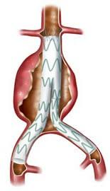
EVAR planning objectives:  - Understand the principles of EVAR planning  - Be able to assess a AAA suitability for EVAR  - Be able to select appropriate endovascular device | EVAR deployment objectives:  - Able to successfully deploy an EVAR device in a simulated environment  - Understand features and applicability of different EVAR devices  - Graft choices  - Closure devices, characteristics & indications

Peripheral: flow model and simulators
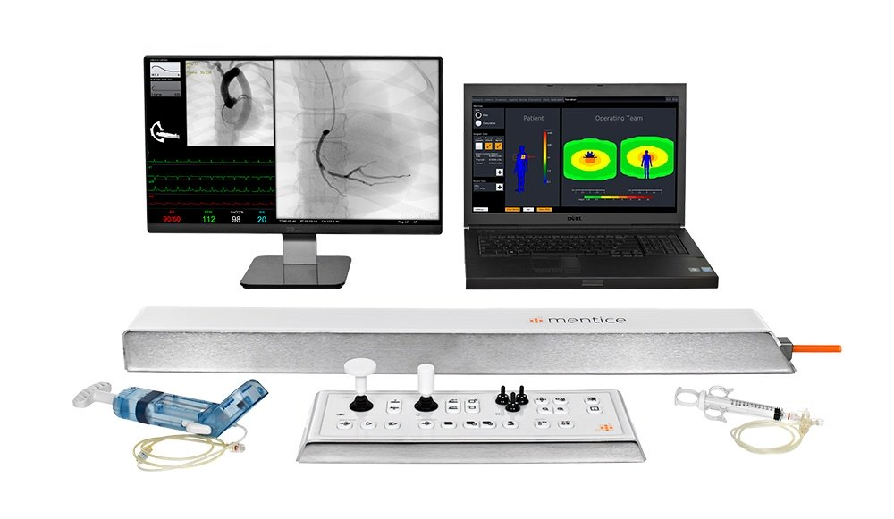
Knowledge:  - Guidewire, catheter, introducer, dilator and sheath types, characteristics and indication  - Balloon and stent types | Practical skills:  - Appropriate selection of equipment  - Manipulate catheter and wire across stenosis

Clinical Skills: clinical scenarios, arterial duplex and open surgery

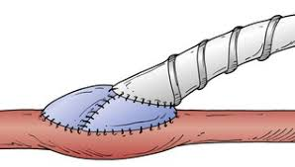

Scenarios:  - Assessment and management of patients with vascular disease  - Knowledge of technical skills | Duplex:  - Understand the principles of Doppler Ultrasound  - Perform an elementary scan of the peripheral/extracranial carotid circulation | Open Surgery  - Perform a simulated Wolf Boot  - Perform a simulated Miller Vein Cuff on below knee popliteal

Case-based discussion: upper limb, diabetic foot, vascular access
Upper Limb:  - Understand common causes of upper limb vascular problems  - Be aware of care and management of UL vascular problems | Diabetic Foot:  - Understand the aetiology of diabetic foot problems  - Be aware of the strategies to prevent and manage diabetic foot complications | Vascular Access:  - Understand the principles guiding vascular access decision making  - Be aware of the care and management of clinical access complications



Format
DAY 1: 08:30-17:40
TIME | SESSION | VENUE
08:30-08:50 | Registration and coffee | The Arena Bar
08:50-09:00 | Welcome and introduction | Hexagon theatre
09:00-10:30 | CBD’s or lectures | Hexagon & Pinsent Masons
10:30-10:45 | Coffee | The Arena Bar
10:45-12:45 | Practical sessions | Breakout rooms
12:45-13:30 | Lunch | The Arena Bar
13:30-17:30 | Practical sessions | Breakout rooms
17:30-17:40 | Feedback and close | Hexagon theatre
19:00 for 19:45 | Faculty dinner | Bank (B1 2JB)

DAY 2 and 3: 08:45-17:40
TIME | SESSION | VENUE
08:45-09:00 | Registration and coffee | The Arena Bar
09:00-10:30 | CBD’s or lectures | Hexagon & Pinsent Masons
10:30-10:45 | Coffee | The Arena Bar
10:45-12:45 | Practical sessions | Breakout rooms
12:45-13:30 | Lunch | The Arena Bar
13:30-17:30 | Practical sessions | Breakout rooms
17:30-17:40 | Feedback and close | Hexagon theatre
19:15- | Programme dinner (Day 2) | Asha’s (B3 3LX)

 | 09:00-10:30 | 10:45-12:45 | 13:30-14:30 | 14:30-17:30
1. AORTIC | CBD’s  Hexagon Theatre | Planning  Saintbury | Planning  Saintbury | Deployment **  Bryant

 | 09:00 – 10:30 | 10:45-12:45 |  | 13:30-15:30 | 15:30-17:30
2. PERIPHERAL | Peripheral lecture  Pinsent Masons 1 | Simulator 1  Pinsent Masons 1 |  | Simulator 2  Pinsent Masons 1 | Flow model  Pinsent Masons 1

 | 09:00 – 10:30 | 10:45-12:45 | 13:30-15:30 | 15:30-17:30
3. CLINICAL | Arterial duplex lecture  Pinsent Masons 2 | Clinical scenarios  Cole | Open surgery  Roughley | Arterial Duplex  Pinsent Masons 2
**Human Factors session with Fiona Kerray

FACULTY
CONVENOR | Anna Murray | Consultant Vascular Surgeon, UHB
FACULTY | Julien Al-Shakarchi | Consultant Vascular Surgeon, Worcestershire Royal
 | Tom Barker | Consultant Vascular Surgeon, UHB
 | Dan Carradice | Senior Lecturer in Vascular Surgery, Hull York Medical School
 | Martin Claridge | Consultant Vascular Surgeon, UHB
 | James Cragg | Consultant Vascular Surgeon, Worcestershire Royal
 | Nikesh Dattani | Consultant Vascular Surgeon, Leicester Vascular Institute
 | Maciek Juszczak | Consultant Vascular Surgeon, UHB
 | Fiona Kerray | Human Factors & Digital Education Fellow, RCSEd & VS
 | Paul Moxey | Consultant Vascular Surgeon, St Georges London
 | Hosaam Nasr | Consultant Vascular Surgeon, UHB
 | Philip Nicholl | Consultant Vascular Surgeon, UHB
 | David Russell | Consultant Vascular Surgeon, Leeds Teaching Hospital
 | Sophie Renton | Consultant Vascular Surgeon, Northwick Park
 | Rachel Sam | Consultant Vascular Surgeon, UHB
 | Mark Scriven | Consultant Vascular Surgeon, UHB
 | Alok Tiwari | Consultant Vascular Surgeon, UHB
 | Haren Wijesinghe | ST6 Interventional Radiology, UHB
 | Massimo Vessozi | Consultant Vascular Surgeon, UHB
SUPPORT | Clive Allen | Vascular Specialist Nurse, UHB
 | Sarah Harley | Vascular Specialist Nurse, UHB
 | Ivan Kalik | Vascular Scientist, UHB
 | Jiji Lucas | Vascular Specialist Nurse, UHB
 | Xian Shen | Vascular Scientist, UHB
*UHB – University Hospitals Birmingham
INDUSTRY
ABBOTT | Claire Viner |  | Territory Manager
 | Helen Carter |  | Territory Manager
COOK | Julie Warren |  | Divisional Support Manager PAD and access
 | Heather Garnet |  | Regional Business Manager UK North and Ireland
 | Liz Goodman |  | Senior Clinical Specialist
 | Louise Reardon |  | Clinical Specialist
 | Deborah Osborne |  | Account Specialist
 | Lynne Teece |  | Account Specialist
GETINGE | Aaron Bagley |  | National Sales Manager
GORE | Stephen Bonnett |  | Aortic Division Clinical Associate
 | Iain Mackintosh |  | Aortic Division Clinical Associate
 | Harriet Tanner |  | Aortic Division Clinical Associate
TERUMO | Sue Arthur |  | Access and Closure Field Technical Specialist

THANKS TO:
 | Joanne Lightfoot |  | UHB Vascular Secretary
 | Claire Acey |  | PA to Professor Chetter, Royal Infirmary Hull
 | Louise Collins |  | Executive Business Support
 | Matthew Ryan |  | Executive Business Support

TRAINEES
A | Gary Cuthbert |  | Yorkshire and Humber
 | Jade Whing |  | Eastern
 | Kamran Gaba |  | Wessex
 | Shaneel Patel |  | North West
 | Terri-Ann Russell |  | East Midlands
 | Pasha Normahani |  | London
 | Osman Eltayar |  | London
 | Kevin McKevitt |  | Ireland
B | Emily Chan |  | Yorkshire and Humber
 | Andrew Nickinson |  | Wessex
 | Albagir Altahir |  | Northern
 | John Houghton |  | East Midlands
 | Florence Kashora |  | London
 | Patrick Wood |  | Ireland
 | Bilal Azhar |  | London
 | Adam Haque |  | North West
C | Noman Shahzad |  | Yorkshire and Humber
 | Tamer El Sayed |  | Northern
 | Ewa Zywicka |  | South West
 | Leanna Erete |  | London
 | Madlen Dewi |  | Wales
 | Amy Lee Fowler |  | Ireland
 | Aadil Ahmed |  | West Midlands
 | Nathalie Doolan |  | Ireland
 | Ahmed Bakr |  | London

GROUP A | 09:00-10:30 | 10:45-12:45 | 13:30-14:30 | 14:30-17:30
DAY 1: | CBD’s | Planning |  | Deployment
AORTIC | ALL | Gary Cuthbert  Jade Whing  Kamran Gaba  Shaneel Patel |  | Terri-Ann Russell  Pasha Normahani  Osman Eltavar  Kevin McKevitt
 |  | Planning |  | Deployment
 |  | Terri-Ann Russell  Pasha Normahani  Osman Eltavar  Kevin McKevitt |  | Gary Cuthbert  Jade Whing  Kamran Gaba  Shaneel Patel
DAY 2: | 09:00-10:30 | 10:45-12:45 | 13:30-15:30 | 15:30-17:30
PERIPHERAL | Peripheral lecture | Simulator 1 | Simulator 2 | Flow model
 | ALL | Gary Cuthbert  Terri-Ann Russell  Shaneel Patel | Jade Whing Pasha Normahani | Kamran Gaba  Osman Eltavar  Kevin McEvitt
 |  | Simulator 1 | Simulator 2 | Flow model
 |  | Kamran Gaba  Osman Eltavar  Kevin McEvitt | Gary Cuthbert  Terri-Ann Russell  Shaneel Patel | Jade Whing  Pasha Normahani
 |  | Simulator 1 | Simulator 2 | Flow model
 |  | Jade Whing Pasha Normahani | Kamran Gaba  Osman Eltavar  Kevin McEvitt | Gary Cuthbert  Terri-Ann Russell  Shaneel Patel
DAY 3: | 09:00-10:30 | 10:45-12:45 | 13:30-15:30 | 15:30-17:30
CLINICAL | Duplex lecture | Clinical Scenarios | Open Surgery | Arterial Duplex
 | ALL | Jade Whing  Terri-Ann Russell  Osman Eltavar | Jade Whing  Terri-Ann Russell  Osman Eltavar | Shaneel Patel  Kamran Gaba  Pasha Normahani
 |  | Clinical Scenarios | Open Surgery | Arterial Duplex
 |  | Shaneel Patel  Kamran Gaba  Pasha Normahani | Jade Whing  Terri-Ann Russell  Osman Eltavar | Jade Whing  Terri-Ann Russell  Osman Eltavar
 |  | Clinical Scenarios | Open Surgery | Arterial Duplex
 |  | Jade Whing  Terri-Ann Russell  Osman Eltavar | Shaneel Patel  Kamran Gaba  Pasha Normahani | Jade Whing  Terri-Ann Russell  Osman Eltavar

GROUP B | 09:00-10:30 | 10:45-12:45 | 13:30-15:30 | 15:30-17:30
DAY 1: | Duplex lecture | Clinical Scenarios | Open Surgery | Arterial Duplex
CLINICAL | ALL | Emily Chan  Andrew Nickinson  Adam Haque | Albagir Altahir  John Houghton | Florence Kashora  Patrick Wood  Bilal Azhar
 |  | Clinical Scenarios | Open Surgery | Arterial Duplex
 |  | Florence Kashora  Patrick Wood  Bilal Azhar | Emily Chan  Andrew Nickinson  Adam Haque | Albagir Altahir  John Houghton
 |  | Clinical Scenarios | Open Surgery | Arterial Duplex
 |  | Albagir Altahir  John Houghton | Florence Kashora  Patrick Wood  Bilal Azhar | Emily Chan  Andrew Nickinson  Adam Haque
DAY 2: | 09:00-10:30 | 10:45-12:45 | 13:30-14:30 | 14:30-17:30
AORTIC | CBD’s | Planning |  | Deployment
 | ALL | Emily Chan  Albagir Altahir  Florence Kashora  Bilal Azhar |  | Andrew Nickinson  John Houghton  Patrick Wood  Adam Haque
 |  | Planning |  | Deployment
 |  | Andrew Nickinson  John Houghton  Patrick Wood  Adam Haque |  | Emily Chan  Albagir Altahir  Florence Kashora  Bilal Azhar
DAY 3: | 09:00-10:30 | 10:45-12:45 | 13:30-15:30 | 15:30-17:30
PERIPHERAL | Peripheral lecture | Simulator 1 | Simulator 2 | Flow model
 | ALL | Adam Haque  Emily Chan  Patrick Wood | Andrew Nickinson  Albagir Altahir  Florence Kashora | Bilal Azhar  John Houghton
 |  | Simulator 1 | Simulator 2 | Flow model
 |  | Bilal Azhar  John Houghton | Adam Haque  Emily Chan  Patrick Wood | Andrew Nickinson  Albagir Altahir  Florence Kashora
 |  | Simulator 1 | Simulator 2 | Flow model
 |  | Andrew Nickinson  Albagir Altahir  Florence Kashora | Bilal Azhar  John Houghton | Adam Haque  Emily Chan  Patrick Wood

GROUP C | 09:00-10:30 | 10:45-12:45 | 13:30-15:30 | 15:30-17:30
DAY 1: | Peripheral lecture | Simulator 1 | Simulator 2 | Flow model
PERIPHERAL | ALL | Noman Shahzad  Tamer El Sayed  Ewa Zywicka | Leanna Erete  Madlen Dewi | Amy Lee Fowler  Aadil Ahmed  Nathalie Doolan
 |  | Simulator 1 | Simulator 2 | Flow model
 |  | Amy Lee Fowler  Aadil Ahmed  Nathalie Doolan | Noman Shahzad  Tamer El Sayed  Ewa Zywicka | Leanna Erete  Madlen Dewi
 |  | Simulator 1 | Simulator 2 | Flow model
 |  | Leanna Erete  Madlen Dewi | Amy Lee Fowler  Aadil Ahmed  Nathalie Doolan | Noman Shahzad  Tamer El Sayed  Ewa Zywicka
DAY 2: | 09:00-10:30 | 10:45-12:45 | 13:30-15:30 | 15:30-17:30
CLINICAL | Duplex lecture | Clinical Scenarios | Open Surgery | Arterial Duplex
 | ALL | Madlen Dewi  Noman Shahzad  Amy Lee Fowler | Tamer El Sayed  Leanna Erete  Aadil Ahmed | Nathalie Doolan  Ewa Zywicka
 |  | Clinical Scenarios | Open Surgery | Arterial Duplex
 |  | Nathalie Doolan  Ewa Zywicka | Madlen Dewi  Noman Shahzad  Amy Lee Fowler | Tamer El Sayed  Leanna Erete  Aadil Ahmed
 |  | Clinical Scenarios | Open Surgery | Arterial Duplex
 |  | Tamer El Sayed  Leanna Erete  Aadil Ahmed | Nathalie Doolan  Ewa Zywicka | Madlen Dewi  Noman Shahzad  Amy Lee Fowler
DAY 3: | 09:00-10:30 | 10:45-12:45 | 13:30-14:30 | 14:30-17:30
AORTIC | CBD’s | Planning |  | Deployment
 | ALL | Nathalie Doolan  Madlen Dewi  Aadil Ahmed  Tamer El Sayed |  | Ewa Zywicka  Noman Shahzad  Amy Lee Fowler  Leanna Erete
 |  | Planning |  | Deployment
 |  | Ewa Zywicka  Noman Shahzad  Amy Lee Fowler  Leanna Erete |  | Nathalie Doolan  Madlen Dewi  Aadil Ahmed  Tamer El Sayed

