From: Elaine Mckeown <Elaine.Mckeown@fitwise.co.uk>
Sent: 22 December 2016 12:34
To: michellecooper@hotmail.co.uk
Subject: Vascular Societies Annual Scientific Meeting - Certificates of Attendance

Dear Michelle
Thank you for attending The Vascular Societies’ Annual Scientific Meeting 2016. We hope you enjoyed your time and found the conference both educational and enjoyable.
Please see below your certificate of attendance
If you require a certificate covering workshop attendance please do not hesitate to contact us.
Photographs taken during the event are now available to view at:
http://simonparvin.com/f942639714
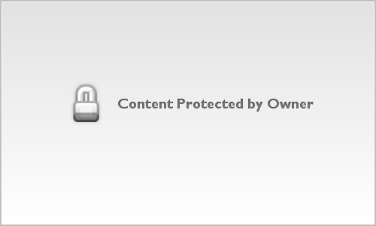 | VS2016  simonparvin.com  Simon Parvin

Password: VS2016
Visitors will need to supply their name and email address.
Kind regards
The Vascular Societies’ Event Team
Fitwise Management Ltd
Tel: 01506 292042
Email: events@fitwise.co.uk
Certificate of Attendance
Certifies to all that
Michelle Cooper
attended
The Vascular Societies' Annual Scientific Meeting
Wednesday 1 November - Friday 2 December 2016, Manchester Central
Registration Type
SVT Member - Thu and Fri
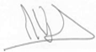 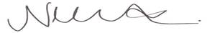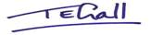
Mike Wyatt, President, The Vascular Society
Nikki Fenwick, President, Society for Vascular Nursing
Tracey Gall, President, Society for Vascular Technology

