Wonderful Theresa, thank you.

Marcia Owen |  |  |  |  |  |  | 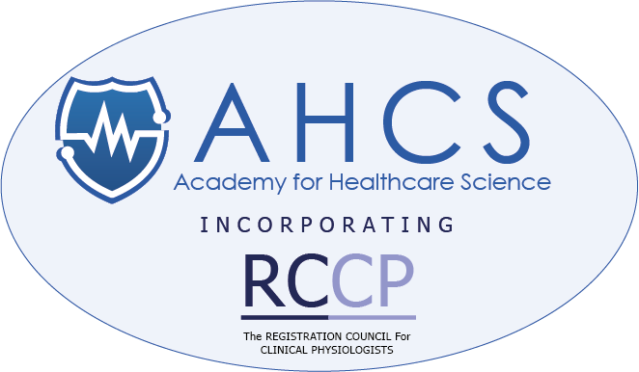
Administration Assistant | Academy for Healthcare Science
T: 07539 934360 | E: marcia.owen@ahcs.ac.uk | W: www.ahcs.ac.uk

 |  |  | 

DISCLAIMER: The information contained in this email is intended only for the personal and confidential use of the recipient(s) named above. If the reader of this communication is not the intended recipient(s) or the person responsible for delivering this communication to the intended recipient(s), you are hereby notified that you have received this communication in error and that any review, dissemination, distribution or copying of this message is strictly prohibited. If you have received this communication in error, please notify us immediately and delete the original message. Thank you. Registered Office: 6 The Terrace, Rugby Road, Lutterworth, Leicestershire, LE17 4BW. Registered in England & Wales Number 07783650.
The Academy for Healthcare Science is committed to being transparent about how we collect and use data and to meeting its data protection obligations. The Academy’s Privacy Notices which reflect the requirement of General Data Protection Regulations (GDPR) can be accessed on www.ahcs.ac.uk/gdpr.

From: theresa fail <theresa.fail@outlook.com>
Sent: 30 March 2022 14:32
To: Marcia Owen <marcia.owen@ahcs.ac.uk>
Subject: RE: AHCS - HSSE Assessment

Hi Marcia
Yes, I can help with this!

BW

Theresa

Sent from Mail for Windows

From: Marcia Owen
Sent: 30 March 2022 12:23
To: Theresa Fail
Subject: AHCS - HSSE Assessment

Dear Theresa

I have a candidate who has submitted their HSSE Application and I am wondering if you might have any spare time to assess this as a Clinical Assessor.

I quite understand if you don’t feel you have time but shall look forward to hearing from you either way.

Regards

Marcia Owen |  |  |  |  |  |  | 
Administration Assistant | Academy for Healthcare Science
T: 07539 934360 | E: marcia.owen@ahcs.ac.uk | W: www.ahcs.ac.uk

 |  |  | 

DISCLAIMER: The information contained in this email is intended only for the personal and confidential use of the recipient(s) named above. If the reader of this communication is not the intended recipient(s) or the person responsible for delivering this communication to the intended recipient(s), you are hereby notified that you have received this communication in error and that any review, dissemination, distribution or copying of this message is strictly prohibited. If you have received this communication in error, please notify us immediately and delete the original message. Thank you. Registered Office: 6 The Terrace, Rugby Road, Lutterworth, Leicestershire, LE17 4BW. Registered in England & Wales Number 07783650.
The Academy for Healthcare Science is committed to being transparent about how we collect and use data and to meeting its data protection obligations. The Academy’s Privacy Notices which reflect the requirement of General Data Protection Regulations (GDPR) can be accessed on www.ahcs.ac.uk/gdpr.

