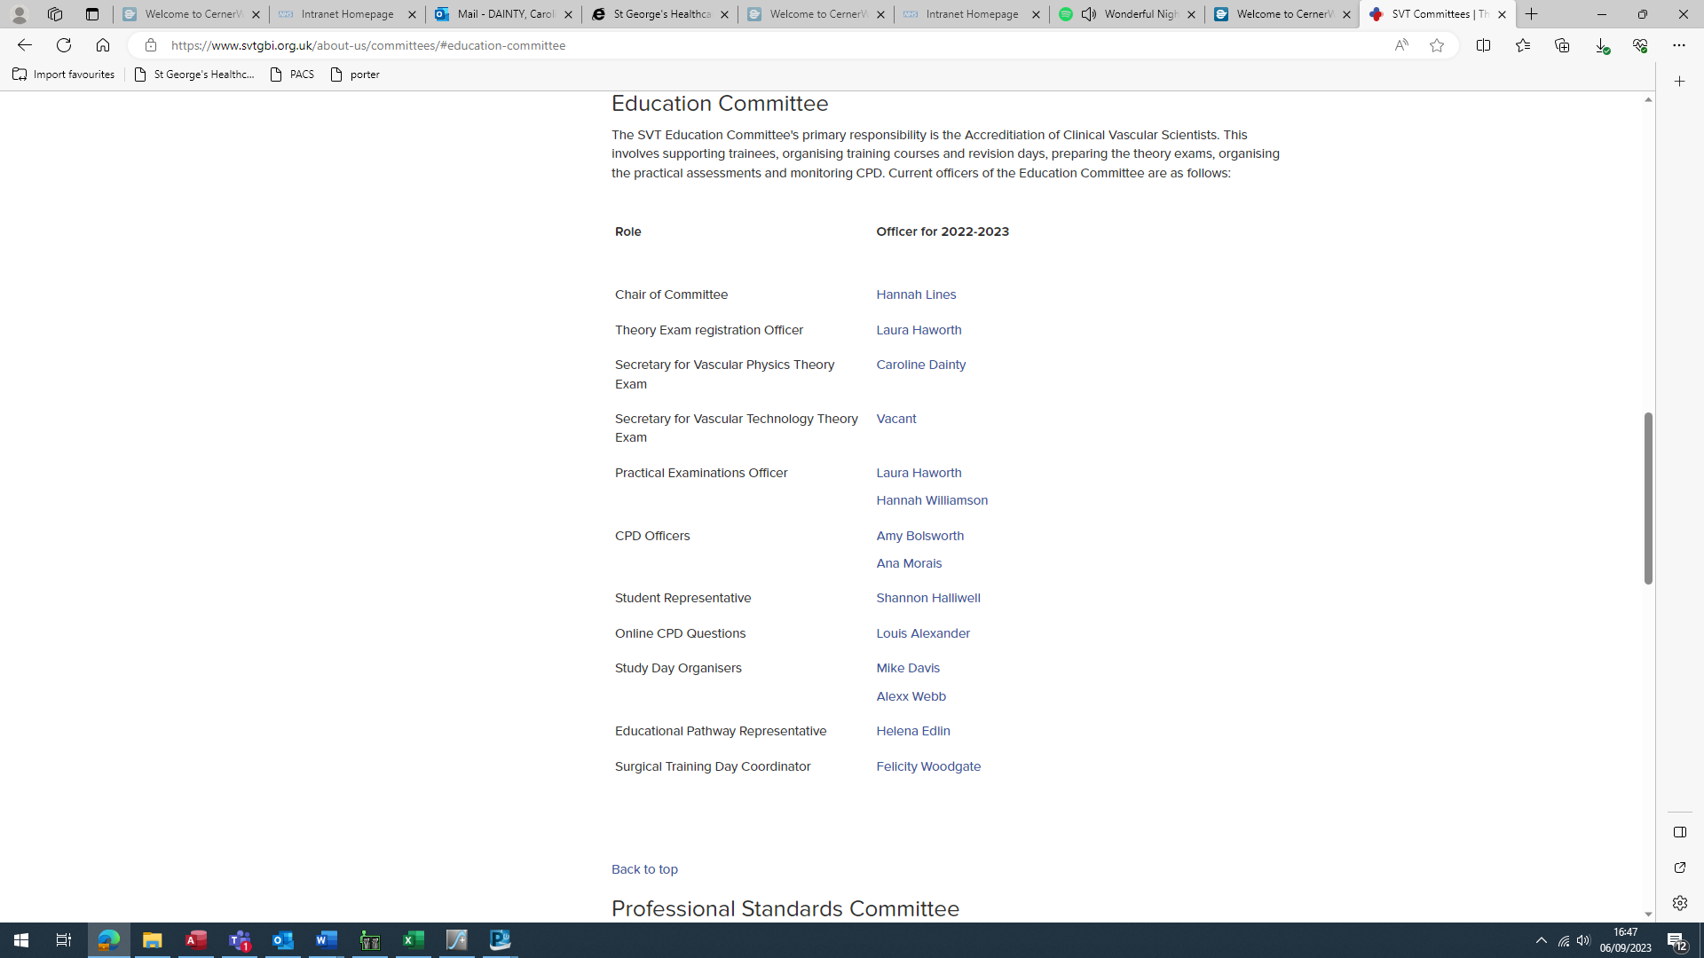

- Screenshot from the SVT website listing the members of the SVT Education Committee.
- SVT Evidence for Caroline Dainty, demonstrating membership of the SVT Education Committee.

