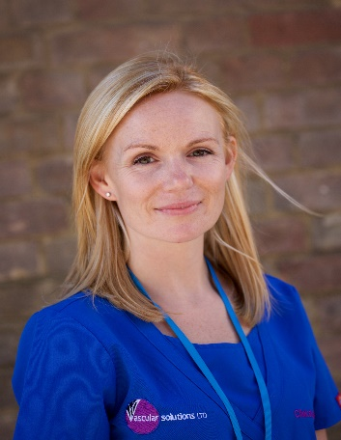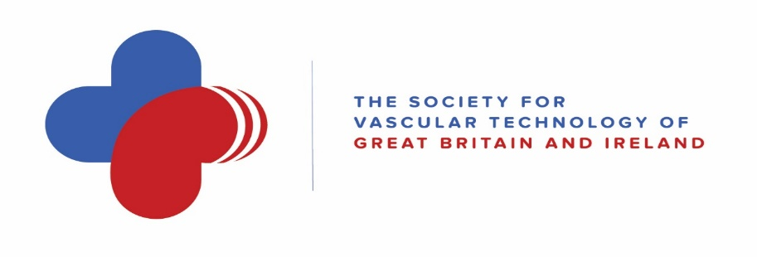
Emma Waldergrave – President
Having spent almost nine years on the Executive Committee in various roles such as Conference Secretary, BMUS representative and Vice president, I now step into my two-year tenure as President of the SVT.
It is a great honour to undertake the role and I hope to make it a successful term with increased access to education and training for both junior and advanced practitioners alike among other goals.
I would like to thank my fellow committee members across all four committees for the role they undertake and their consistent hard work. Without the voluntary work of our committee members the SVT would not be the esteemed professional voice it is today.
Research
The SVT continues to award research grants to Clinical Vascular Scientists and we are fortunate enough to be in a position to award up to £10000 per annum towards to support research activity by the membership. We believe that this funding is crucial in supporting / encouraging the membership to continue their research activities whilst offering a clinical service within the NHS with the outcomes presented at the annual scientific meeting. Our research committee are at hand to support and guide those wishing to undertake original research.
BMUS
We are pleased to be asked to deliver the vascular stream at BMUS 2022 in Cardiff. As the leading society for Vascular science / imaging we believe that we are perfectly placed to lead the way at a national level with scientific talks, hand on sessions and access to SVT Professional Performance Guidelines.
Education
We continue to provide study days, online theory exams and webinars throughout the year for our membership. After a successful vascular imaging study day at the Vascular Societies’ ASM in Manchester 2021 we are pleased to provide another hands-on session and teaching day for vascular professionals and trainees in Brighton. A special thanks to our education committee for delivering such a fantastic hands-on experience supported by first class talks on current protocols and topics.
Thirtieth Anniversary Statement
The Society for Vascular Technology of Great Britain & Ireland (SVT) became a registered charity in 1992. The Society brings together those performing vascular physiological and imaging assessments. Over the past thirty years we have seen many improvements and changes such as the development and roll out of a national aortic aneurysm screening programme, centralisation of vascular services, modernising scientific careers and a COVID-19 response to name a few. Notable improvement included creation of the first national structured training, teaching and assessments of Clinical Vascular Scientists culminating in certification in the form of Accredited Clinical Vascular Scientist (AVS) status which is still held in great esteem globally.
Standardisation and quality improvement are central to future. To achieve this the SVT pioneered nationally agreed protocols and guidelines available as a starting point for Vascular services. All of this has enabled an extension of the AVS role from assessing and reporting disease into administering surveillance programmes, liaising with GPs, leading in vascular outpatient clinics and performing endovascular intervention. Delivering all these services in a safe manner highlights the quality of training and robustness of our accreditation process.
More recently Brexit has become a recognised challenge. The UK has always been a stronghold of vascular technological development. The deviation from European Certification (CE) marking to UKCA marking poses the biggest threat to maintaining our world leading status as a research leader. Ensuring early access to emerging technology other than from deep pockets of multinationals is easily the biggest challenge we face in the next decade. Our Society has come a long way in the last thirty years and we look forward to a future with a stronger, better trained and more vibrant workforce.
I would like to personally thank all current and past committee members for their unstinting work in achieving such a magnificent national and international profile for our society.

