Certificate of attendance
This is certify that

J Parkinson
Attended
The Annual North West Vascular meeting
Held on the 16 October 2017 At the
Novotel, Worsley, Manchester

This meeting has been accredited 4 CPD by the
Royal College of Surgeons of England

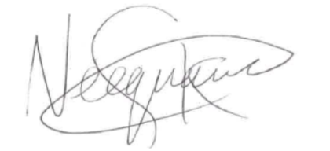
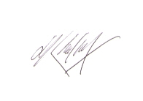
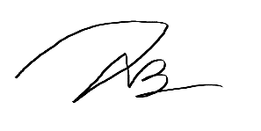

--------------------------------- -------------------------- ---------------------------
S Neequaye N B Teo H Al-Khaffaf

Organising Committee

